Technical Story Card

Revision History
Version No. | Date | Prepared by / Modified by | Significant Changes
1 | 07-03-2022 | Anusha Chava  NagendraBabu Gunduboina  SudhaRani Asam
2 | 16-03-2022 | Anusha Chava | ScreenShots Added

Glossary
Abbreviation | Description
BSC | Business Story Card
TSC | Technical Story Card

Table of Contents
1 Introduction 4
2 Scope of Change 4
3 List of impacted modules 4
4 Design and Detailed technical updates 5
4.1 Process model 5
4.1.1 Use case Model 5
4.1.2 Sequence diagram 15
5 References 16

Introduction
Life is becoming too busy to get medical appointments in person and to maintain a proper health care. The main idea of this work is to provide ease and comfort to patients while taking appointment from doctors and it also resolves the problems that the patients has to face while making an appointment.
The system aims to help the patients to make appointments online through the internet and track their records through it. Doctor Appointment Booking System has been facing problems due to its paper-based appointment system. With the increase in the number of patients visiting, it has become difficult to manage the appointment system manually.
The purpose of this project is to solve these complications by creating custom-built database software to manage the appointment system. For the user/patient, it makes it easy to set a date and time for the treatment of the patient to the relevant doctor.It also helps to maintain the doctor's consultation fee. Above all, it helps to develop a simple user interface to help the user with the doctors’ arrangement.

Scope of Change
The system has been facing problems due to its paper-based appointment system. So The Doctor Appointment booking system is a web application that gives a solution to the polyclinic patients.This system manages complete booking details in a single application and in a single database. The users will use this system to handle all the functionalities easily. The intentions of the system are to reduce overtime pay and increase the number of patients that can be treated accurately. Requirements statements in this document are both functional and non-functional.

List of impacted modules
All the functional modules will be created from scratch. Doctor Appointment Application contains three modules. One module is the patient needs to be registered and log in after logging on he/she can search for the doctor by giving the location, the reason or problem. Basing on the doctor availability the admin will confirm the booking request and will send to mail that the booking is confirmed he can also view in the status and he can also give feedback basing the performance of the doctor .Doctor need to be registered by giving the necessary details like experience, timing, fees etc. After registering he need to log in and in the home screen he can view the basic functionalities. He can view the patient request forwarded from admin and he can accept and he can also view the feedback given by patients. After, it allows the patient to select to the doctor that he prefers and complete the appointment and fee payment.

Design and Detailed technical updates

Process model

Use case Model
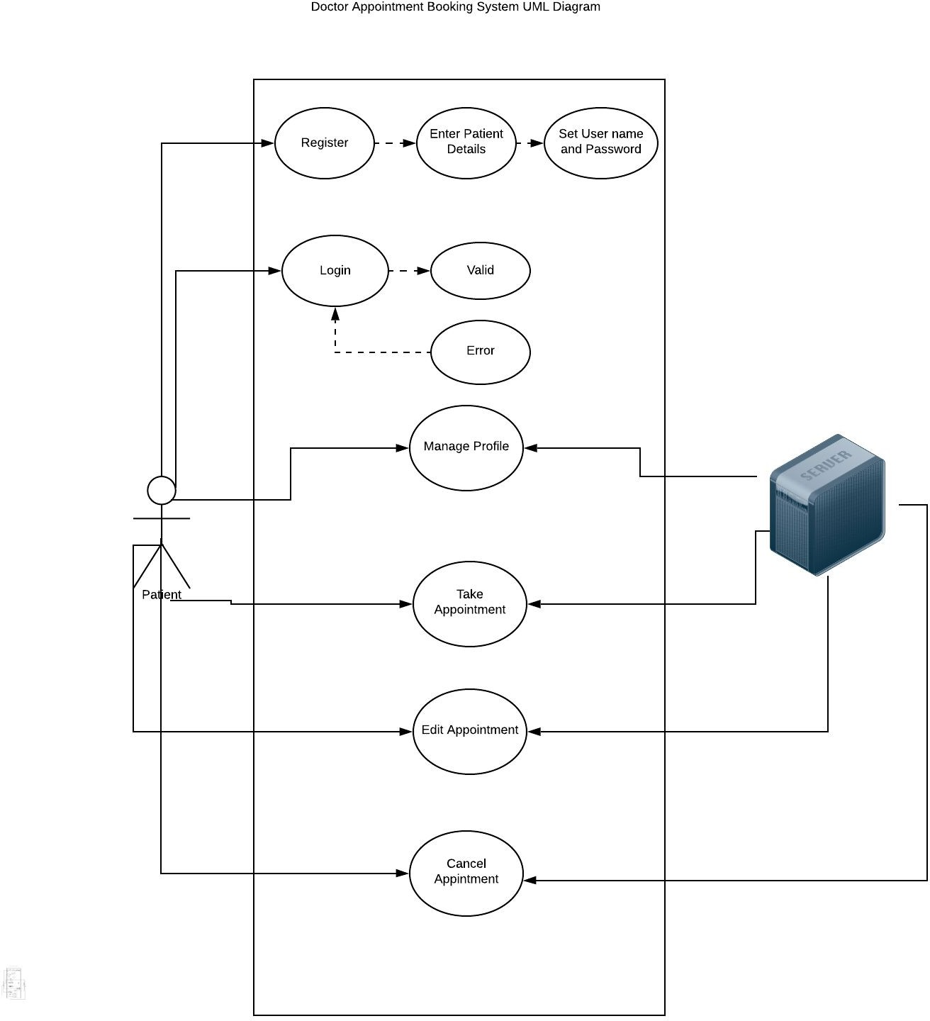

Brief Description | Patient Registration
Basic Flow | This use case describes how a patient register into the system  - The patient has to register himself into the system.  - After the successful registration, patient will get a success message.  - The following information is required during registration.  - ITR No  - Name  - Phone  - Date  - Address  - Age  - Gender  - Marital Status  - Disease  - Doctor Name
Alternate Flow | - The system will validate the information provided. If any invalid data is found, the input form will be redirected with error message.
Validation | - Username is required and minimum 3 characters and max 30 characters.  - The Password should be same as Re-Entered Password.  - Contact Number must be valid.
Pre-Conditions | Patients should have network access and Browser with latest updates.
Post-Conditions | Success message should be shown.

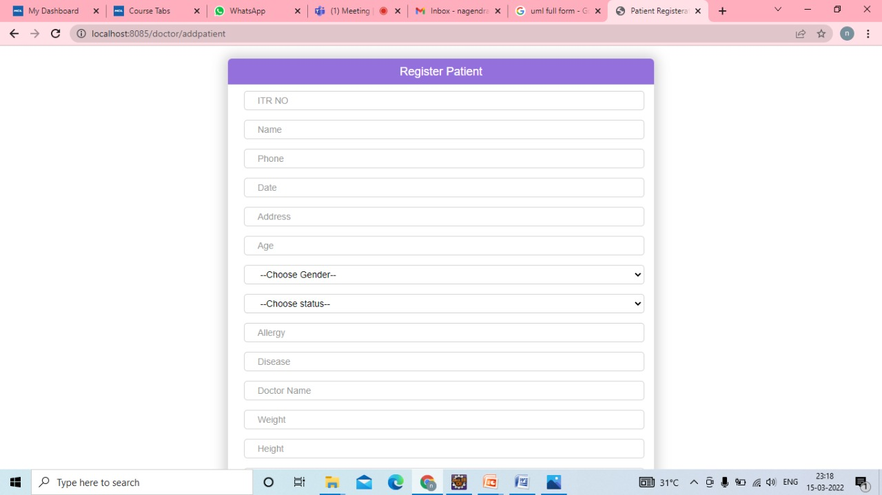

Brief Description | Doctor Registration
Basic Flow | This use case describes how a doctor register in to the system  - The doctor has to register himself into the system.  - After the successful registration, doctor will get a success message.  - The following information is required during registration.  - Id  - Name  - Email  - Username  - Password  - Phone  - Gender  - Section  - Actions
Alternate Flow | - The system will validate the information provided. If any invalid data is found, the input form will be redirected with error message.
Validation | - Name is required and minimum 3 characters and max 30 characters.  - The Email should be valid.  - Contact Number must be valid.
Pre-Conditions | Doctor should have network access and Browser with latest updates.
Post-Conditions | Success message should be shown.

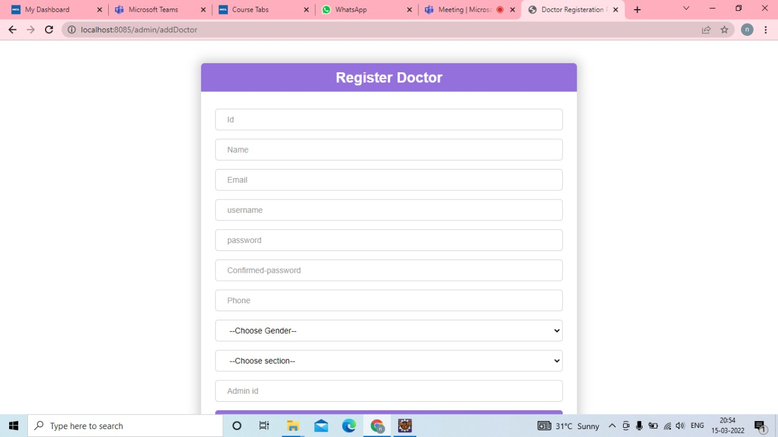

Brief Description | Login
Basic Flow | This use case describes how a user log-in in to the system  - The patient has to register himself into the system.  - After the successful login, user will be taken to the appropriate landing page.  - The following information is required to login.  - Email Id  - Username  - password
Alternate Flow | - The system will validate the credentials provided. If credentials are invalid, login form will be redirected again with error message.
Validation | - Valid username  - Valid password
Pre-Conditions | User should have network access and Browser with latest updates.
Post-Conditions | Landing page has to be displayed.

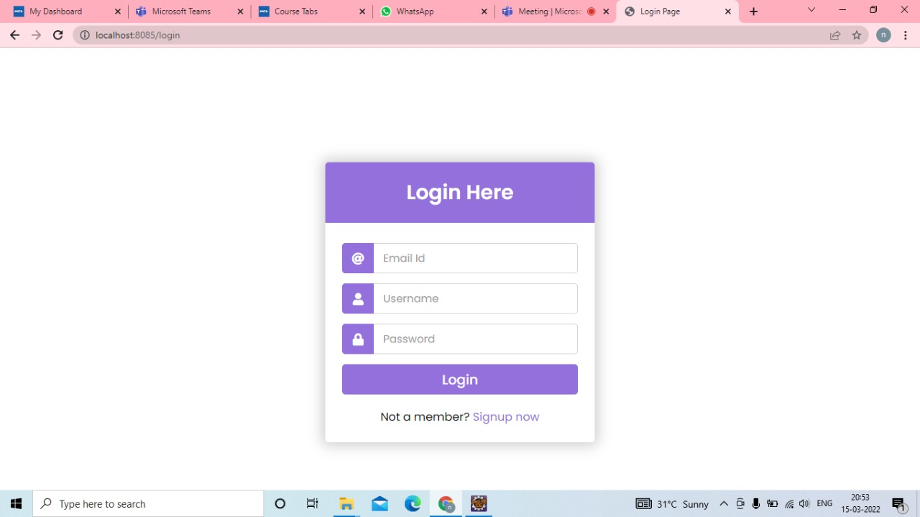

Brief Description | Admin
Basic Flow | This use case describes how a patient can view the status of the appointment list.  - The patient has to login into the system.  - The following information is required.  - Patient Name  - Doctor Name  - Time Schedule  - DD/MM/YYYY  - Serial Number  - Fee
Alternate Flow | - The system will validate the information provided. If any invalid data is found, the input form will be redirected with error message.
Validation | - Patient Name is required and minimum 3 characters and max 30 characters.  - Doctor Name is required and minimum 3 characters and max 30 characters.
Pre-Conditions | User should have already logged into the system.
Post-Conditions | Success message should be shown.

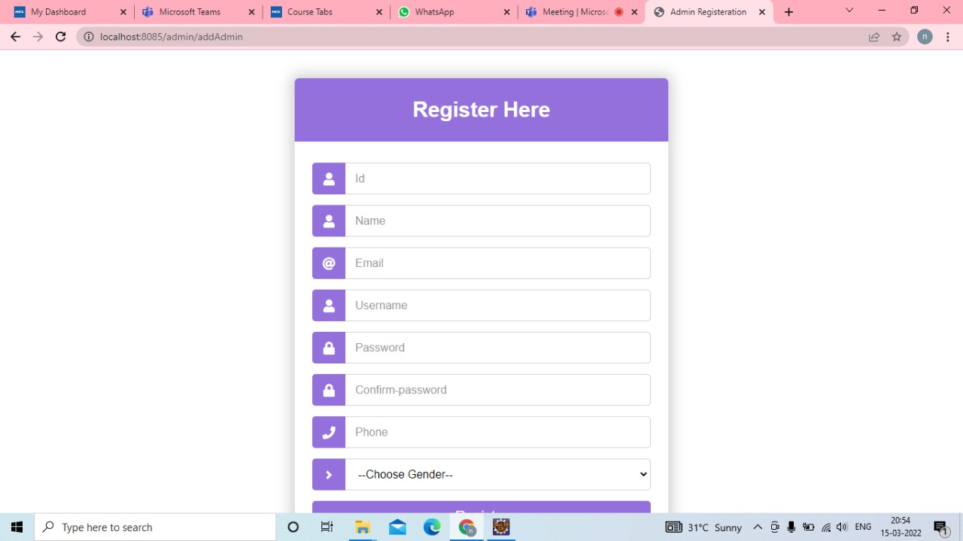

Brief Description | Contact Us
Basic Flow | This use case describes how a Patient can Contact with the Hospital.  - The patient has to login into the system.  - Allows patient to search based on following attributes.  - Name  - Email  - Phone  - Message
Alternate Flow | Not Applicable
Validation | Not Applicable
Pre-Conditions | Patient should have already logged into the system.
Post-Conditions | Success message should be shown.

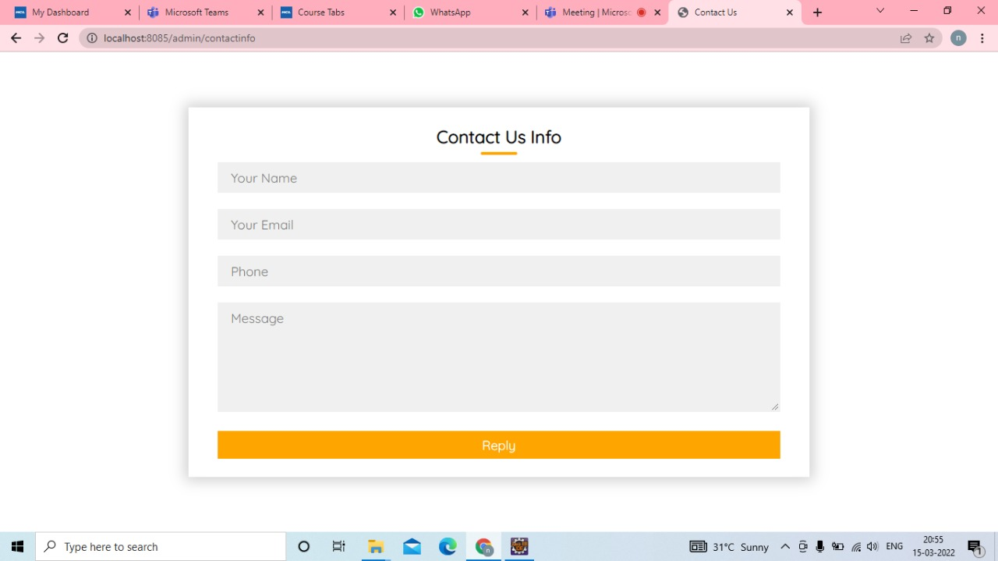

Architecture Diagram

Layer
Logical View
Technology/ Framework

UI Components
Presentation Layer
HTML/ CSS/ JavaScript
Export (pdf)
Validations
Resources

Report

Web-Server Classes
Java 1.8/ Spring Boot
Application/ Business Layer
Configuration
Controllers

Service
REST Controllers

Entity/ Model Classes

Data Access Layer
Spring JPA/Spring Hibernate
Repository classes

Oracle 11g Database

Presentation Layer:
This layer consists of all UI components.
- Export component: The plug-in is used to export the reports in pdf format. It helps to reduce the workload on the web/ application server.
- Validation component: All basic level data validations should be done at UI level.
- Report component: All reports to be generated to the user, will be processed and generated at the browser end.
- Resources: All HTML/CSS/ images, which are required for the page design.
Application Layer:
This layer comprises of all server and business classes.
- Configuration settings (XML or Class based) will define the application and server configuration.
- Spring Controllers defines the server classes, which are required to process the incoming http requests.
- Service classes are required to perform the required business services.
- REST Controllers to process the HTTP AJAX requests.
- Model classes are used the define the functions of the entities present in the system.
Data Layer:
Data layer is implemented through Hibernate ORM. It will contain the repository classes, which provides interface to the table.

Class Diagram

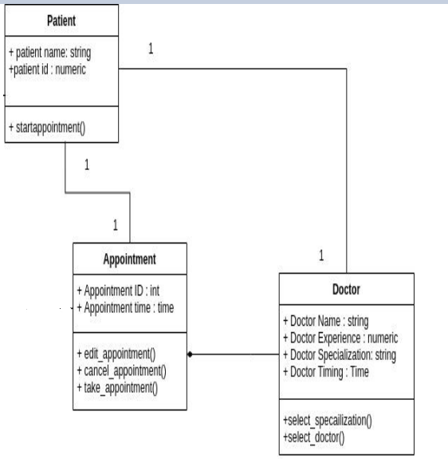

Sequence diagram

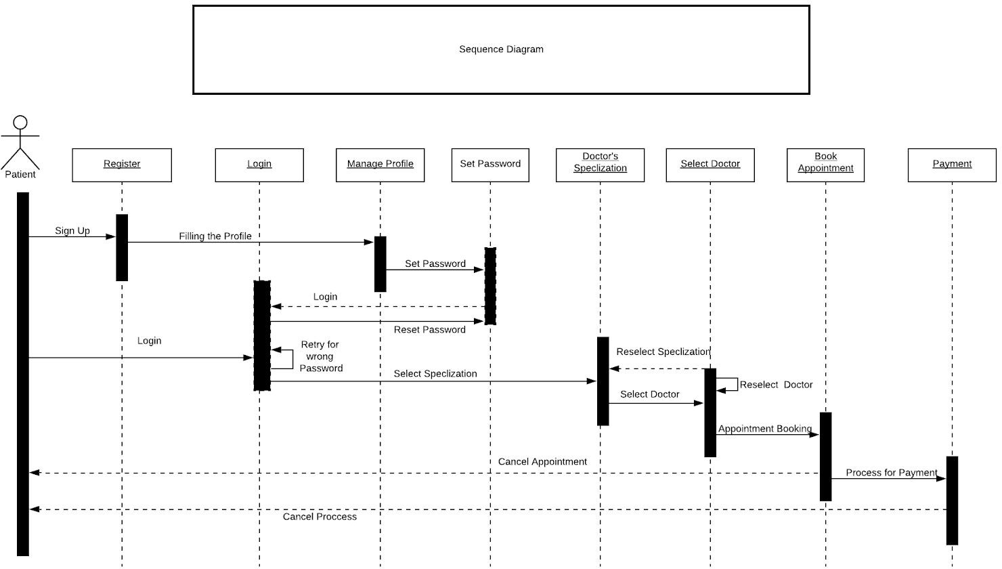

References

- https://www.freeprojectz.com/uml-diagram/doctor-appointment-system-uml-diagram
- https://www.w3schools.com/howto/howto_css_register_form.asp
- https://stackoverflow.com/questions/5012335/how-to-connect-html-pages-to-mysql-database

